**Sprint 3 tasks:**

* Creating Dashboard

**Sales By sub category and sales by region:**

Visualization represents the sales by sub category and sales by region.

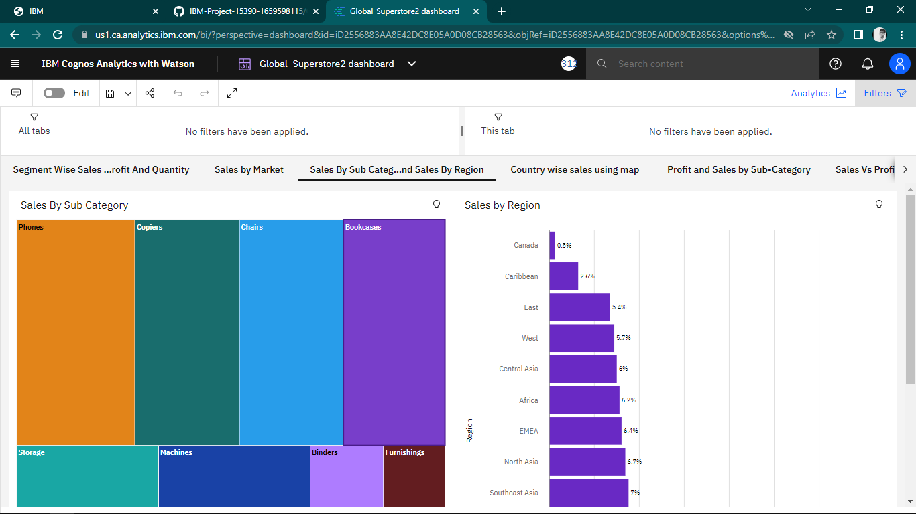

**Country wise sales using map points:**

Geo maps provides insights of sales by country.

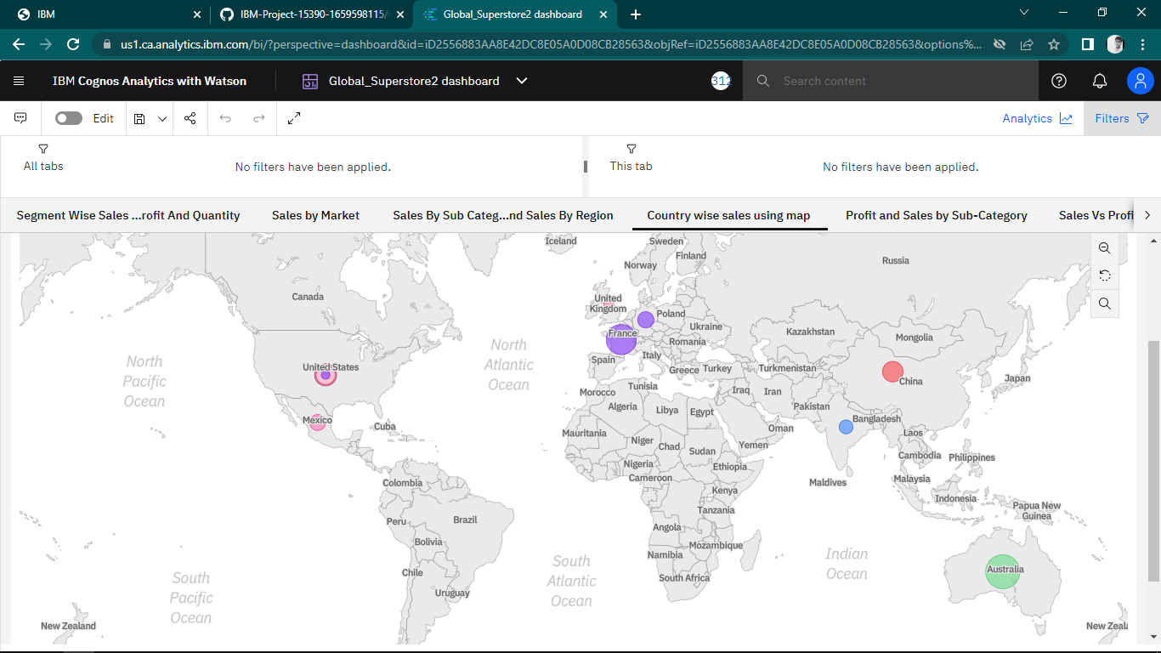

**Sub Category Wise Sales And Profits Using Line And Bar Chart:**

Sales vs Profit are represented in the below combinational visualization - Bar represents the sales by sub-Category and the Line represents the Profit by Sub-Category. Sub Category Wise Sales and Profits using Line and Bar Chart.

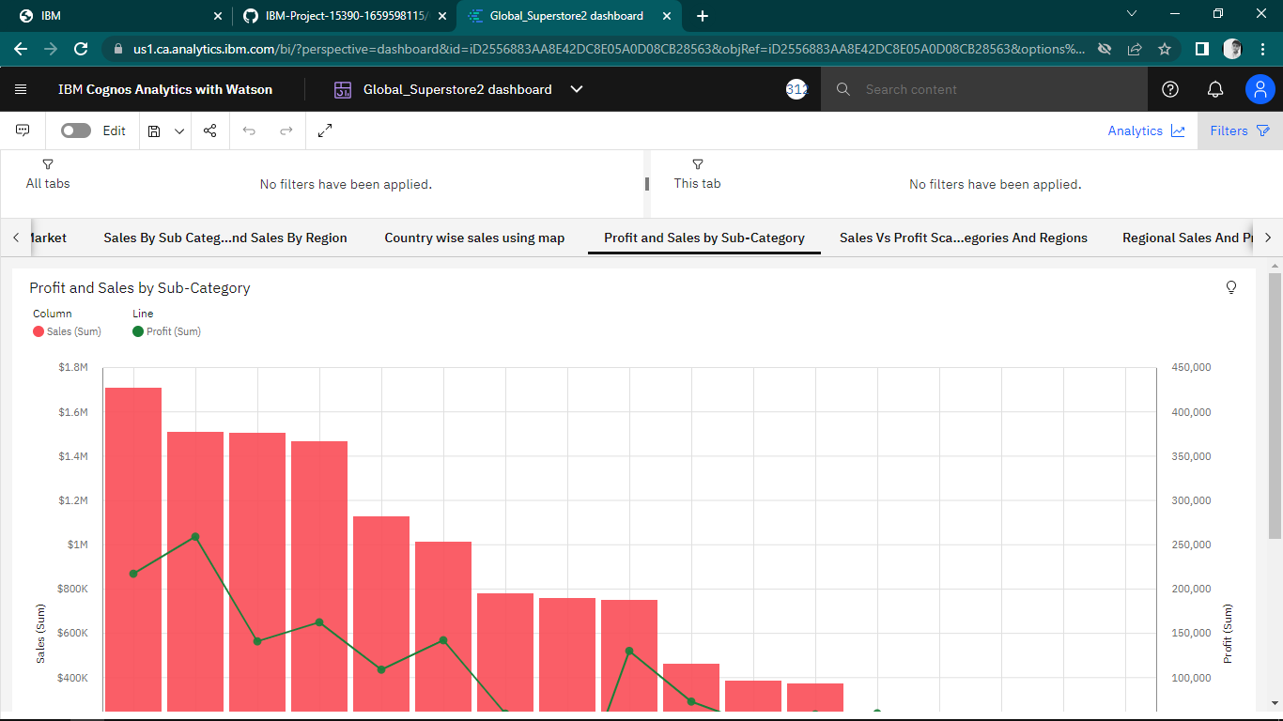

**Sales Vs Profit Scatter Plot with Sub Categories and Regions:**